Lab Session 10: K-Nearest Neighbors Algorithm

How K-Nearest Neighbors Algorithm Work?
K-Nearest Neighbors, or KNN for short, is one of the simplest machine learning algorithms It is used in many different fields. KNN is called a non-parametric algorithm, which means it does not assume anything about the data. It simply looks at how close a new data point is to other data points and uses that information to make a decision. KNN is also called a lazy learning algorithm because it does little or no training in advance. Instead, when a new data point comes in, KNN looks at the closest existing data points and classifies the new point immediately. In simple words we can say that, KNN finds the closest data points and uses them to decide what the new data point should be.
Pros:
- No assumptions about data
- Simple algorithm — easy to understand
- Can be used for classification and regression
Cons:
- High memory requirement — All of the training data must be present in memory in order to calculate the closest K neighbors
- Sensitive to irrelevant features i.e. unimportant features can affect the result.
- Sensitive to the scale of the data since we’re computing the distance to the closest K points. It means that, features with larger values can have more effect on the result than features with smaller values.

Implementing and Evaluating the K-Nearest Neighbors Algorithm
- Pick a value for K (i.e. 5).
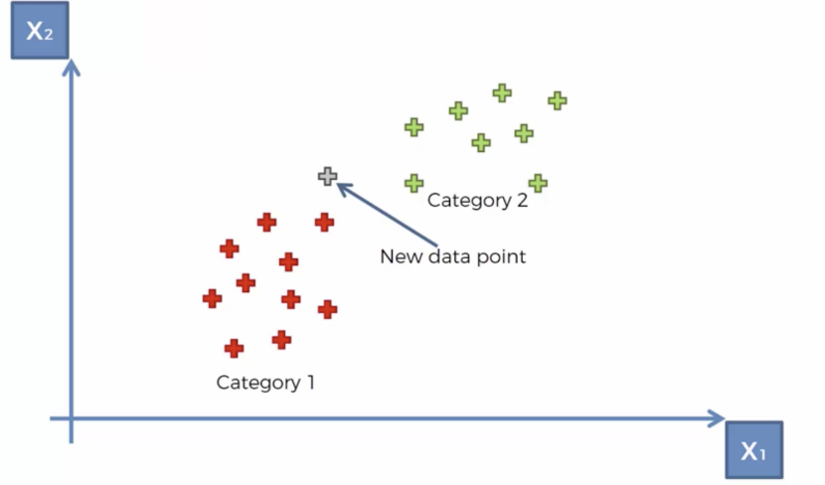
2. Take the K nearest neighbors of the new data point according to their Euclidean distance.

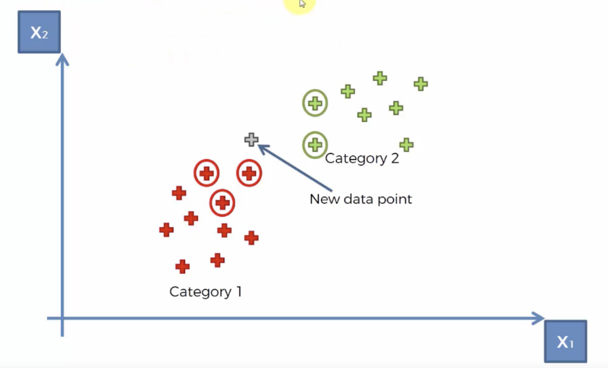
3. Among these neighbors, count the number of data points in each category and assign the new data point to the category where you counted the most neighbors.

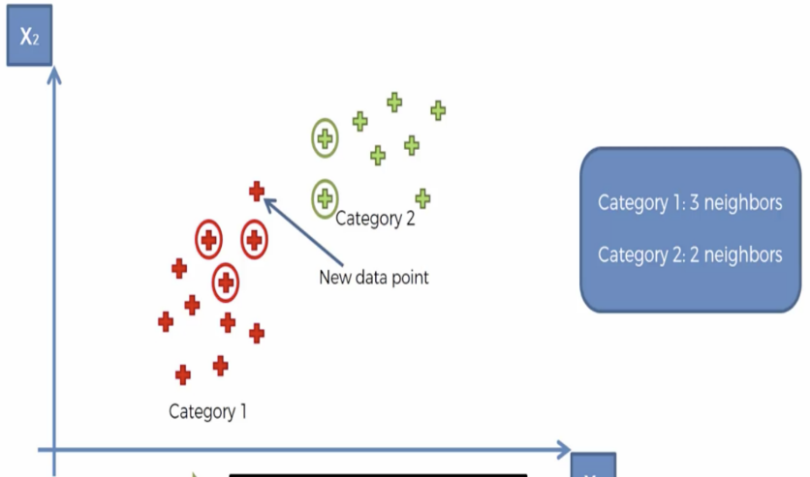
Code
Let’s take a look at how we could go about classifying data using the K-Nearest Neighbors algorithm in Python. For this tutorial, we’ll be using the breast cancer dataset from the sklearn.datasets module. We need to start by importing the proceeding libraries.
# Import necessary libraries
import numpy as np # For numerical computations
import pandas as pd # For handling data in tabular form (DataFrames)
from matplotlib import pyplot as plt # For visualizing data
from sklearn.datasets import load_breast_cancer # Load the breast cancer dataset
from sklearn.metrics import confusion_matrix # For evaluating model performance
from sklearn.neighbors import KNeighborsClassifier # KNN algorithm
from sklearn.model_selection import train_test_split # For splitting the dataset into training and testing sets
import seaborn as sns # For advanced visualization
sns.set() # Set default style for Seaborn plots
The dataset classifies tumors into two categories (malignant and benign) and contains something like 30 features. In the real world, you’d look at the correlations and select a subset of features that plays the greatest role in determining whether a tumor is malignant or not. However, for the sake of simplicity, we’ll pick a couple at random. We must encode categorical data for it to be interpreted by the model (i.e. malignant = 0 and benign = 1).
# Load the breast cancer dataset
breast_cancer = load_breast_cancer()

# Create a DataFrame containing only the selected features 'mean area' and 'mean compactness'
X = pd.DataFrame(breast_cancer.data, columns=breast_cancer.feature_names)
X = X[['mean area', 'mean compactness']] # Select two features to simplify the example

# Convert target labels (malignant and benign) into categorical format and then one-hot encode them
# 'malignant' will be encoded as 0, and 'benign' as 1
y = pd.Categorical.from_codes(breast_cancer.target, breast_cancer.target_names)
y = pd.get_dummies(y, drop_first=True) # Drop the first column to avoid multicollinearity (one-hot encoding)
The point of building a model, is to classify new data with undefined labels. Therefore, we need to put aside data to verify whether our model does a good job at classifying the data. By default, train_test_split sets aside 25% of the samples in the original dataset for testing.
# Split the data into training and testing sets (75% for training, 25% for testing)
X_train, X_test, y_train, y_test = train_test_split(X, y, random_state=1)
The sklearn library has provided a layer of abstraction on top of Python. Therefore, in order to make use of the KNN algorithm, it’s sufficient to create an instance of KNeighborsClassifier. By default, the KNeighborsClassifier looks for the 5 nearest neighbors. We must explicitly tell the classifier to use Euclidean distance for determining the proximity between neighboring points.
# Initialize the KNN classifier with 5 neighbors and Euclidean distance as the metric
knn = KNeighborsClassifier(n_neighbors=5, metric='euclidean')
Using our newly trained model, we predict whether a tumor is benign or not given its mean compactness and area.
# Train the KNN model using the training data
knn.fit(X_train, y_train)

# Predict the labels for the test data (benign/malignant) based on the trained model
y_pred = knn.predict(X_test)
We visually compare the predictions made by our model with the samples inside the testing set.
# Visualize the test data using a scatter plot with Seaborn
# We use 'mean area' and 'mean compactness' to plot, and color the points based on actual labels
sns.scatterplot(
x='mean area',
y='mean compactness',
hue='benign', # Color points by whether they are benign (1) or malignant (0)
data=X_test.join(y_test, how='outer') # Combine feature data and true labels for visualization
)

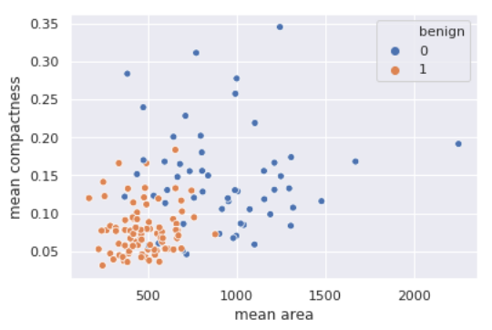
# Overlay the predicted labels on top of the previous scatter plot
# Points are colored based on the predictions made by the KNN model
plt.scatter(
X_test['mean area'],
X_test['mean compactness'],
c=y_pred, # Color points based on predicted labels (benign or malignant)
cmap='coolwarm', # Use a 'coolwarm' color map to distinguish between classes
alpha=0.7 # Add transparency to make points easier to visualize
)

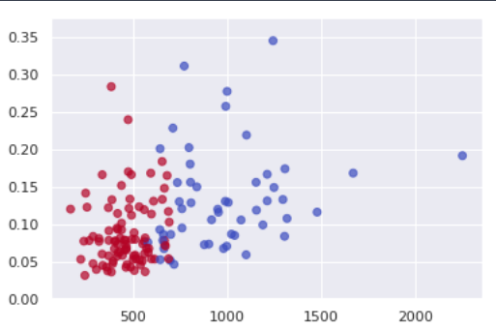
Another way of evaluating our model is to compute the confusion matrix. The numbers on the diagonal of the confusion matrix correspond to correct predictions whereas the others imply false positives and false negatives.
# Display the plot with both true labels and predicted labels
plt.show()

# Compute the confusion matrix to evaluate the model's performance
# Rows represent the actual labels, columns represent the predicted labels
conf_matrix = confusion_matrix(y_test, y_pred)

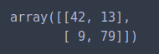

# Print the confusion matrix
print("Confusion Matrix:\n", conf_matrix)

# Calculate accuracy based on the confusion matrix
# The diagonal values represent correct predictions (True Positives and True Negatives)
accuracy = (conf_matrix[0, 0] + conf_matrix[1, 1]) / np.sum(conf_matrix)
print(f"Accuracy: {accuracy * 100:.2f}%")
Given our confusion matrix, our model has an accuracy of 121/143 = 84.62%.
Conclusion
The K Nearest Neighbors algorithm doesn’t require any additional training when new data becomes available. Rather it determines the K closest points according to some distance metric (the samples must reside in memory). Then, it looks at the target label for each of the neighbors and places the new found data point into the same category as the majority. Given that KNN computes distance, it’s imperative that we scale our data. In addition, since KNN disregards the underlying features, it’s our responsibility to filter out any features that are deemed irrelevant.

Lab Task
- Implement the K-nearest algorithm with the given values above.
- Try implementing KNN as a solution for any real life problem/scenario.

